**Daleville, Indiana**

2015-2020 ParkS and Recreation Master Plan

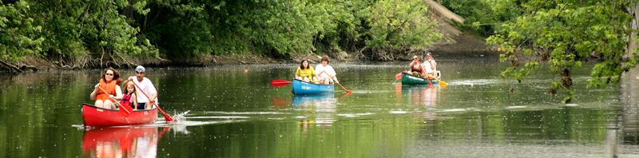

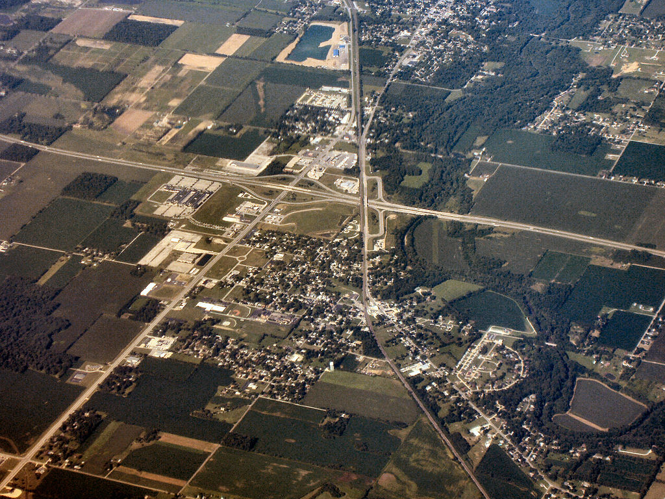

Table of Contents

Introduction 4

Goals and Objectives 7

Features of Service Area 8

Current Facilities Location Map 11

Daleville Parks Department Facilities Inventory List 12

Handicap Accessibility and Universal Design 18

Public Participation 19

Internet Survey Results 20

Needs Analysis 21

Daleville Dream Project 22

Priorities and Action Plan Schedule 26

Appendix Survey Results 27

# Introduction

**The Town of Daleville**

**Community Name:** Town of Daleville

**Community’s Home County:** Delaware

**Address of Park Department or Municipal Building:** Town Hall, 8019 S Walnut St. Daleville, IN. 47334

**Phone Number of Park Department or Municipal Building:** (765) 378-6288

**Year Plan Created:** 2014

**Plan Author Info**

**Name:** Anthony Bobay of Augusta Consulting, LLC.

**Address:** 7504 West Augusta Blvd. Yorktown, Indiana 47396

**Phone number:** (765) 808-1484

**E-mail:** bookout.augusta@gmail.com

**The Parks Board/Department**

**Park Board President’s Name:** Bryce Conyers

**Park Board President’s Term Expiration:** 2016

**Address:** 14124 Katriene Dr, Daleville, IN 47334

**Phone number:** 765-215-0617

**E-mail:** bconyers@gmail.com

**Park Board Vice-President’s Name:** Sean Stewart

**Park Board Vice-President’s Term Expiration**: 2017

**Address:** 7300 S. River Road, Daleville‎ IN. 47334

**Phone number:** (240) 354-1981

**E-mail:** stewart.sean137@gmail.com

**Park Board Secretary’s Name:** Amy Roberts

**Park Board Secretary’s Term Expiration:** 2018

**Address:** 13919 W Main St, Daleville, IN 47334

**Phone number:** (765)425-0036

**E-mail:** [amyjo310@att.net](mailto:amyjo310@att.net)

**Park Board Member’s Name:** Joan Shellabarger

**Park Board Member’s Term Expiration:** 2019

**Address:** 13719 W Main St, Daleville Indiana 47334

**Phone number:** (765)635-4645

**E-mail:** [jssb326@yahoo.com](mailto:jssb326@yahoo.com)

**Park Board Member’s Name:** Julian Ravencroft

**Park Board Member’s Term Expiration**: 2016

**Address:** 14135 W Daleville Rd, Daleville, IN 47334

**Phone number:** (574)780-3256

**E-mail:** [julianravncroft@gmail.com](mailto:julianravncroft@gmail.com)

**Parks Department Fiscal Status**

The current budget for the Daleville Parks program has been $2,000 per year for several years. In 2014 a $10,000 grant was awarded from the Community Foundation of Muncie and Delaware County and $35,000 was pledged from the Daleville TIF District for new trails through Shellabarger Park. In addition, the Daleville Town Board recently passed an ordinance establishing a new tax rate exclusively for the Parks Department. The levy is expected to bring in $11,500 per year starting in May of 2015. It has been overwhelmingly expressed by the citizens of Daleville that the town’s parks are important, and they are willing to assume new tax responsibilities to improve and maintain them.

In addition to these funds, a $4.2 million bond backed by TIF dollars from the Daleville Tax Increment Financing District has been earmarked for a large redevelopment project aimed at revitalizing the Town Hall Park. Ongoing maintenance of the park is expected to be ~$20,000 annually, and will be financed with the revenue generated from a “Town Hall Park Trust” which will pay out 4% of the total fund value every year. Currently, $50,000 has been pledged to the trust, which equates to $2,000 per year, and more funding is currently being sought.

While the money for the Town Hall Park Renovations Project won’t be under the direct management of the parks department, this project will directly affect facilities that are managed by the parks department. It will be the responsibility of the newly created parks department to advise and oversee the improvements to the park, and incorporate the suggestions mentioned in this plan into the renovations. The project is still in the design phase, and no plans for the park have been finalized. The plan is being developed by the urban planning firm, Rundell Ernstberger and Associates, LLC., and is expected to be completed August of 2015. The preliminary master plan for the town can be found on the Daleville website and was also completed by Rundell Ernstberger.

**Definition of the Planning Area**

The facilities of the Daleville parks department mainly serve the residents of Daleville, and some from the neighboring town of Chesterfield and Delaware County. However, the town’s close proximity to the White River and Interstate I-69 lends itself to being a bit of a local recreational destination. The services provided by local canoeing companies allow visitors to canoe the White River to various destinations for a moderate fee. This attraction draws people from all over Indiana and the nearby cities of Anderson and Muncie.

**Map of Daleville Parks Department Service Area**

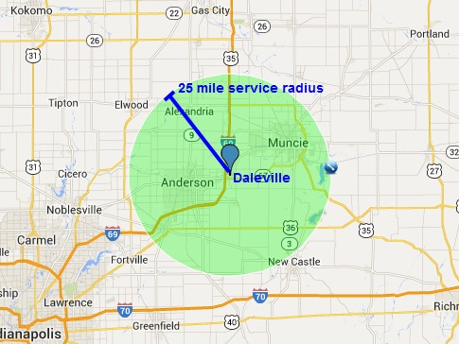

# Goals and Objectives

**Master Plan Goals**

The Daleville 5-Year Parks and Recreation Master Plan has been created to provide both current and future park board members and town planners with a comprehensive analysis of the current parks and recreation situation in Daleville, and suggests potential projects to pursue further. This plan has taken input and suggestions from the community, and provides the town planners guidelines as to what types of park amenities and programs are most desired by the residents. This plan can also be used as a reference guide for future Daleville park master plans, and provides an easy template to work with when updating the plan. Completing this plan will also provide increased access to park funding opportunities, while publishing the park department’s intentions to the state, local residents, and other interested parties.

**Parks Department Mission Statement**

The Daleville Parks Department intends to enrich the lives of its residents by providing high quality, safe parks and recreation facilities as well as a diverse range of recreation activities for people of all ages to enjoy and learn from. Our goal is to provide ample and high quality recreational opportunities to all Daleville residents, as well as those visiting our town.

# Features of Service Area

**Natural Features and Landscape:**

There are many different natural features and landscapes that will contribute to the overall benefit provided by the Daleville Parks Department. The most prominent amongst them is the White River which lies on the northern border of the town and provides both local residents and visitors a wonderful venue to canoe, fish, and view nature.

These geographic features are important to the Daleville Parks department because they provide many of our citizens the ability enjoy nature and park amenities for free. They are also important in attracting and retaining prospective residents to the area because of the desire for a robust parks system. The parks and features can also be used for company picnics and outings, which directly benefits the local government, and in turn the parks department.

**Man-Made, Historical, and Cultural Features:**

Like many Midwestern communities, the Town of Daleville was founded and established mostly due to the convergence of several major transportation corridors in a single area. The Town is located in Southwestern Delaware County, and is located immediately adjacent to three primary transportation corridors that include Interstate 69, State Road 32, and State Road 67. Additionally, the CSX Railroad runs through the center of Daleville, connecting to Anderson on the west, and Yorktown and Muncie to the east. The White River also comprises the northern boundary of Daleville’s corporate limits. These different man-made features are the basis for the Town’s existence, and helps support and stimulate the local economy.

The biggest feature is I-69 which runs through the west side of Daleville, and generates the most amount of traffic to and through the town. Because of its close proximity and importance to the local economy, I-69 cannot be overlooked when creating a strategic plan for the town. Some other major man-made features that contribute to the overall economic health of Daleville and its parks program are State Roads 32 and 67, which run east-west through the center and south side of town, respectively. The CSX railroad that runs through the center of town was the original economic driver and foundation of the town, but is no longer utilized by the local community or economic base today. The state highways, combined with I-69 create a flurry of transportation activity that is critical to growing the town’s commercial and residential areas. The transportation corridors provide excellent access for the town residents to easily commute to the north side of Indianapolis as well as Muncie and Anderson. Very few communities throughout the state have the elaborate state highway connectivity that is present in Daleville. This connectivity will continue to drive the population and economic growth of Daleville.

There are other features in the planning stages in the surrounding area which are not under the direct supervision of the Daleville Parks Department, but will be enjoyed by local residents and visitors. These are the (proposed) Mounds Lake, (proposed) downtown revitalization, and an expanded trail system through the town. Each of these amenities will provide residents with the chance to enjoy recreational opportunities within a short walk of their homes and appreciate the natural beauty of the area.

In addition to these man-made features, Daleville also has a rich cultural history that lends itself to the town’s unique charm and personality. Since its founding in 1838, the town has had a close connection with the White River. Two separate canoe/kayak companies reside in Daleville and attract over 20,000 visitors yearly from outside the town. Daleville would like to capture more revenue from these visitors through sales in local shops and eateries.

One of the biggest cultural features of the surrounding area is the close presence of Ball State University, Anderson University and Ivy Tech. Because these three schools are within the 25 mile service area, they have an active role in the overall economic health of the town. These universities provide students and educated graduates who work in the commercial park, as well as participate in canoeing and other various recreational activities in the town.

The renovations and improvements to the Town Hall Park will allow for the development and expansion of both current and future festivals. The park will have a performance stage, large open field, enhanced playground equipment, and a host of other features that will both enhance the current activities and festivals and provide the necessary infrastructure to create and host new events. Some examples include, concerts in the park, town fitness days, etc. There has even been some talk of shutting down large sections of the town’s roadways in order to host a go-cart grand prix.

There are two main festivals in the Town with Autumnfest and the annual John Dillinger Festival. Autumnfest is held annually on the second weekend of October, and provides guests with carnival rides, food & craft vendors, and entertainment throughout the three day event. The Dillinger Festival, ironically enough, celebrates the day that notorious bank robber John Dillinger robbed the Commercial Bank of Daleville during his bank robbing spree in the 1930’s. These cultural features are unique to Daleville and are very important to the park system because they foster community involvement, spirit, cooperation and pride amongst those who reside in the town and those who visit Daleville for work and recreation.

**Social and Economic Statistics**

Total community Population: 1,647

Community member’s median age: 40

Percentage of community living at or below poverty level: 5.18%

Percentage of community under the age of 18: 22.9%

Percentage of community over the age of 65: 11.8%

Percentage of community members over the age of 5 with a disability: N/A

Breakdown of community by race:

% White: 97.6%

% Black or African American: 0.4%

% Hispanic or Latino (of any Race): 0.5%

% American Indian and Alaska Native: 0.1%

% Asian: 0.7%

% Native Hawaiian and Other Pacific Islander: 0.1%

% Some Other Race: 0.1%

% Two or more Races: 1.0%

Median household income: $44,578

**Largest employers in community:** Concentrix, Element, Fuller Hardwood, Jarden Home Brands, Boyce Forms, First Merchants, DSE Services/Bolt Express

**Economic Overview**

Daleville is currently in the unique economic position of having more jobs available within its city limits than there are residents who live within the town. This creates a situation in which the town has many people from outside its town limits commuting to the area to work. Some of these commuters hail from as far away as Indianapolis, Anderson, Marion, Muncie and New Castle. The constant travel in and out of the town and highway presence helps to support businesses in the area that wouldn’t survive off of the town alone. Because of Daleville’s centralized geographic position relative to the larger cities in surrounding counties, the town has a bright and sustainable future as a transportation hub and service provider.

There are three main business districts in the town that generate the majority of the revenue for the town. They are the Old Town Business District, the New Town Business District, the commercial corridor of Commerce Drive and the Heartland Business Park. The Old Town Business District is currently slated for redevelopment courtesy of a newly created Downtown Revitalization Master Plan. The New Town area is ready for development with newly completed streets, sewers and utility connections. Commerce Drive and the Heartland Business Park is the main engine that drives the economic vitality of the town and is home to the town’s largest employers. Currently there are over 2000 jobs in the Commerce Drive/Heartland Business Park area. Most of the employees commute in and out of Daleville on a daily basis. The town would like to attract these commuters to live in Daleville.

The economic well-being of the town is extremely important for the parks department because it receives almost their entire budget from tax revenue. The Town Board has traditionally relied on the private sector for capital investments and growth, and has mainly focused on providing existing residents with a better quality of life. However, with the newly proposed downtown revitalization plan, Daleville looks to be taking matters into their own hands by utilizing TIF financing from the Daleville TIF district to fund the revitalization of their downtown and parks facilities.

Daleville has come a long way in the last two decades, and the continued growth and expansion occurring on the north east side of Indianapolis has made Daleville an attractive place for both businesses and residents to consider locating. The Town Board and Parks Department are now well positioned with available funds to make significant strides to improve the town’s park systems and add to the amenities currently offered. In anticipation of future growth of the town, these improvements need to happen now. Examples of such efforts include working with the local MPO to develop a better and more robust trail and safety infrastructure, expanding both the size and amount of parks in the town, focusing on transit oriented development, and creating new and enhanced youth programs to handle the influx of new families who will be moving to the town.

# Current Facilities Location Map

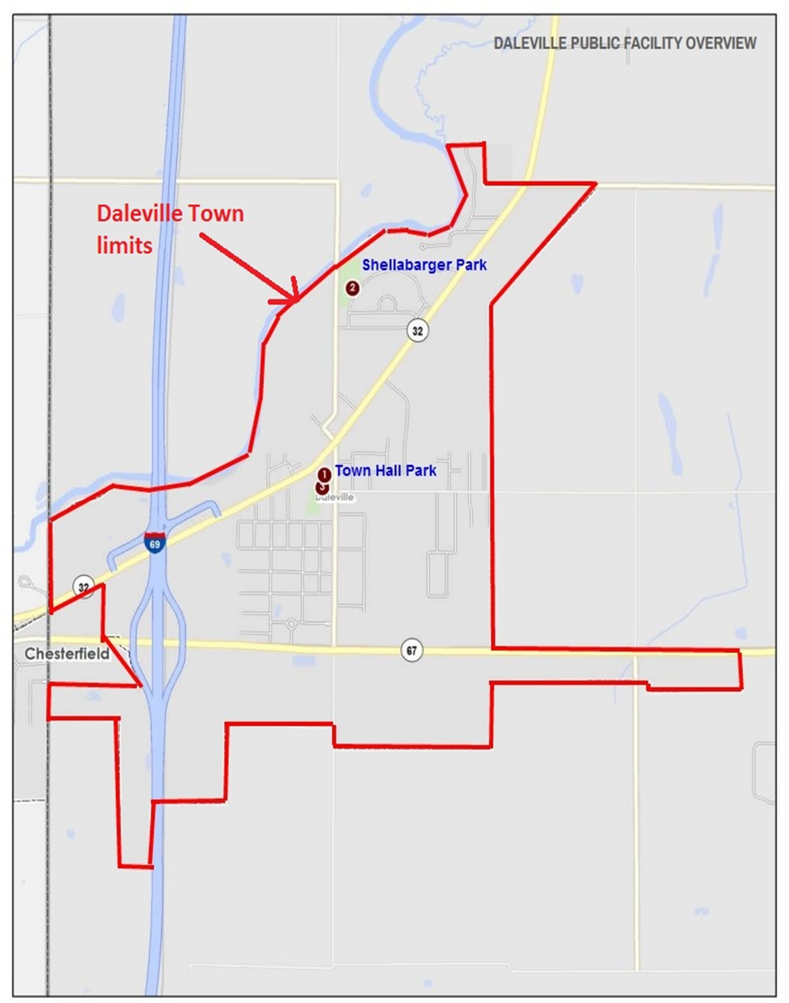

# Daleville Parks Department Facilities Inventory List

**Name of park:** Shellabarger Park

The David E. Shellabarger Park lies north of Daleville along South River Road. This five acre park lies just south of the White River, just east of South River Road, and just northwest of West Hilltop Circle. The address for the park is 14316 Hilltop Circle.

Shellabarger Park sits adjacent to the river and provides residents with an opportunity to enjoy basketball courts, playground equipment, shelter house, trails, nature and exercise health fitness equipment.

Features of the park include:

1. Shelter House
2. Jungle Gym
3. Playground
4. Swing Set
5. Basketball Courts
6. Exercise Health Trail through Woods
7. Grassy Field
8. Trees/Bushes
9. Natural Area
10. Parking Lot
11. Adjacent to Canoe Rental Businesses
12. Adjacent to Residential Subdivision

Map of Shellabarger Park

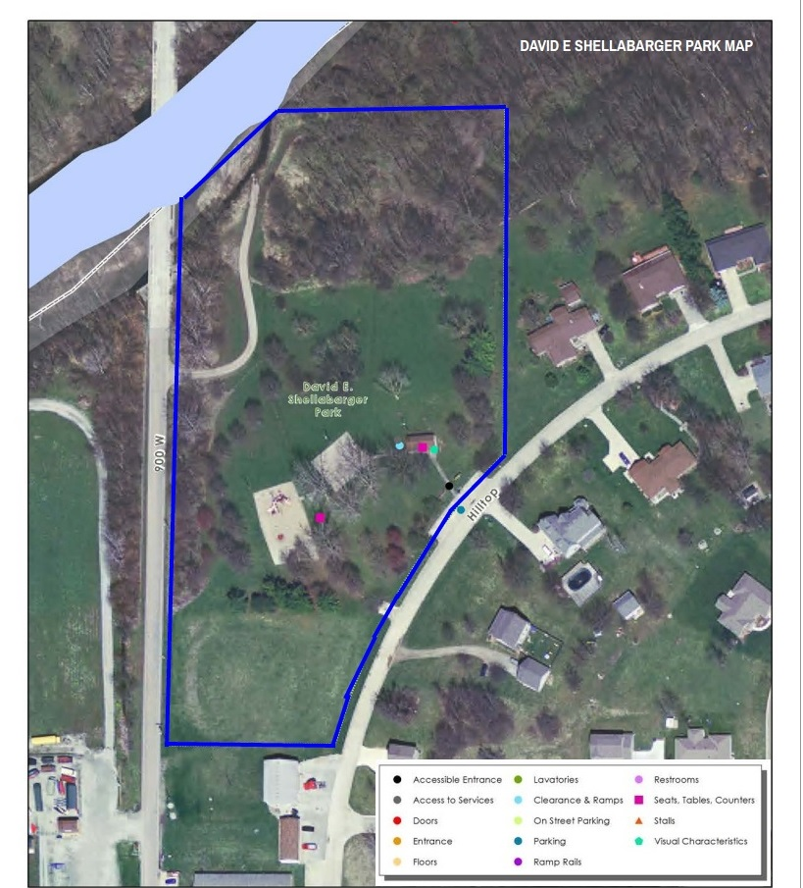

**Name of park:** Town Hall Park

The Daleville Town Hall Park is located at 8020 South Walnut Street, Daleville, Indiana adjacent to the community’s Town Hall and Municipal Complex. The park covers five acres and is considered to be located very near the heart of Old Town Daleville.

The Town Hall Park is located in the heart of Daleville’s Downtown. The park currently offers an open grassed lawn with playground equipment, a gazebo, and shelter house. However, once the proposed renovations are complete, the facility will include everything from a fitness/nature trail, performance stage, concession stands, multi-aged playground equipment, the largest splash pad in East Central Indiana, and lounge areas.

Features of the park include:

1. Shelter (w/Restrooms)
2. Gazebo
3. Jungle gym
4. Swing set
5. Open field

Map of Town Hall Park

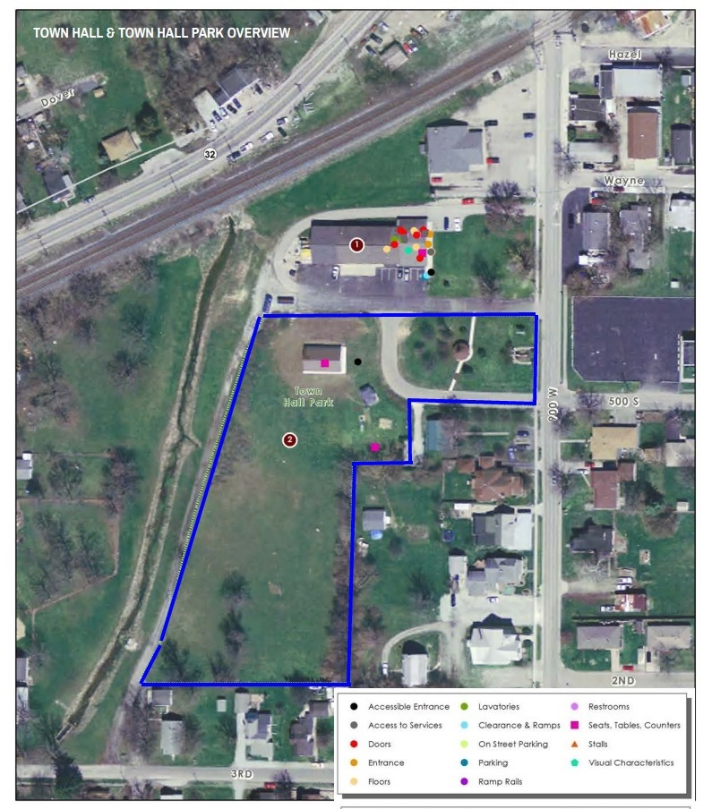

**Name of Park:** Fireman’s Park (Proposed)

Fireman’s Park is a proposed park to be located in the empty lot next to the fire station on W. Daleville Rd. The park will be designed in the style of the Lurie Gardens in Chicago. The park is intended to provide the residents of the community with a relaxing setting to unwind as well as an open field to run around or play sports in. The park will feature a large open field on the north end with the gardens and a gazebo in the south section. The park will be located directly across the street from the school, and should provide outdoor recreational and learning opportunities for the students.

The park is expected to cost a total of $50,000 which will funded through grants and donations. It is also expected to cost ~$2,000 annually in maintenance expenses, and will be maintained by the fire department located next door. The town recently agreed to a tax increase to fund their fire department as part of the town’s new Fire Territory Program.

The town is currently soliciting donations and applying for grant funding to cover the cost of construction of the park. If the fundraising plan goes according to plan, the park could be constructed as early as summer 2016.

**Site Map**

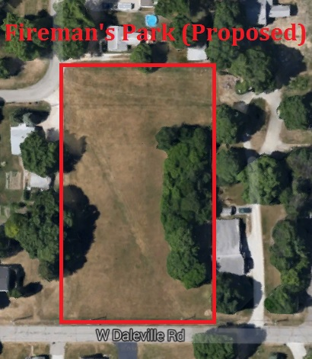

**Fireman’s Park Preliminary Design**

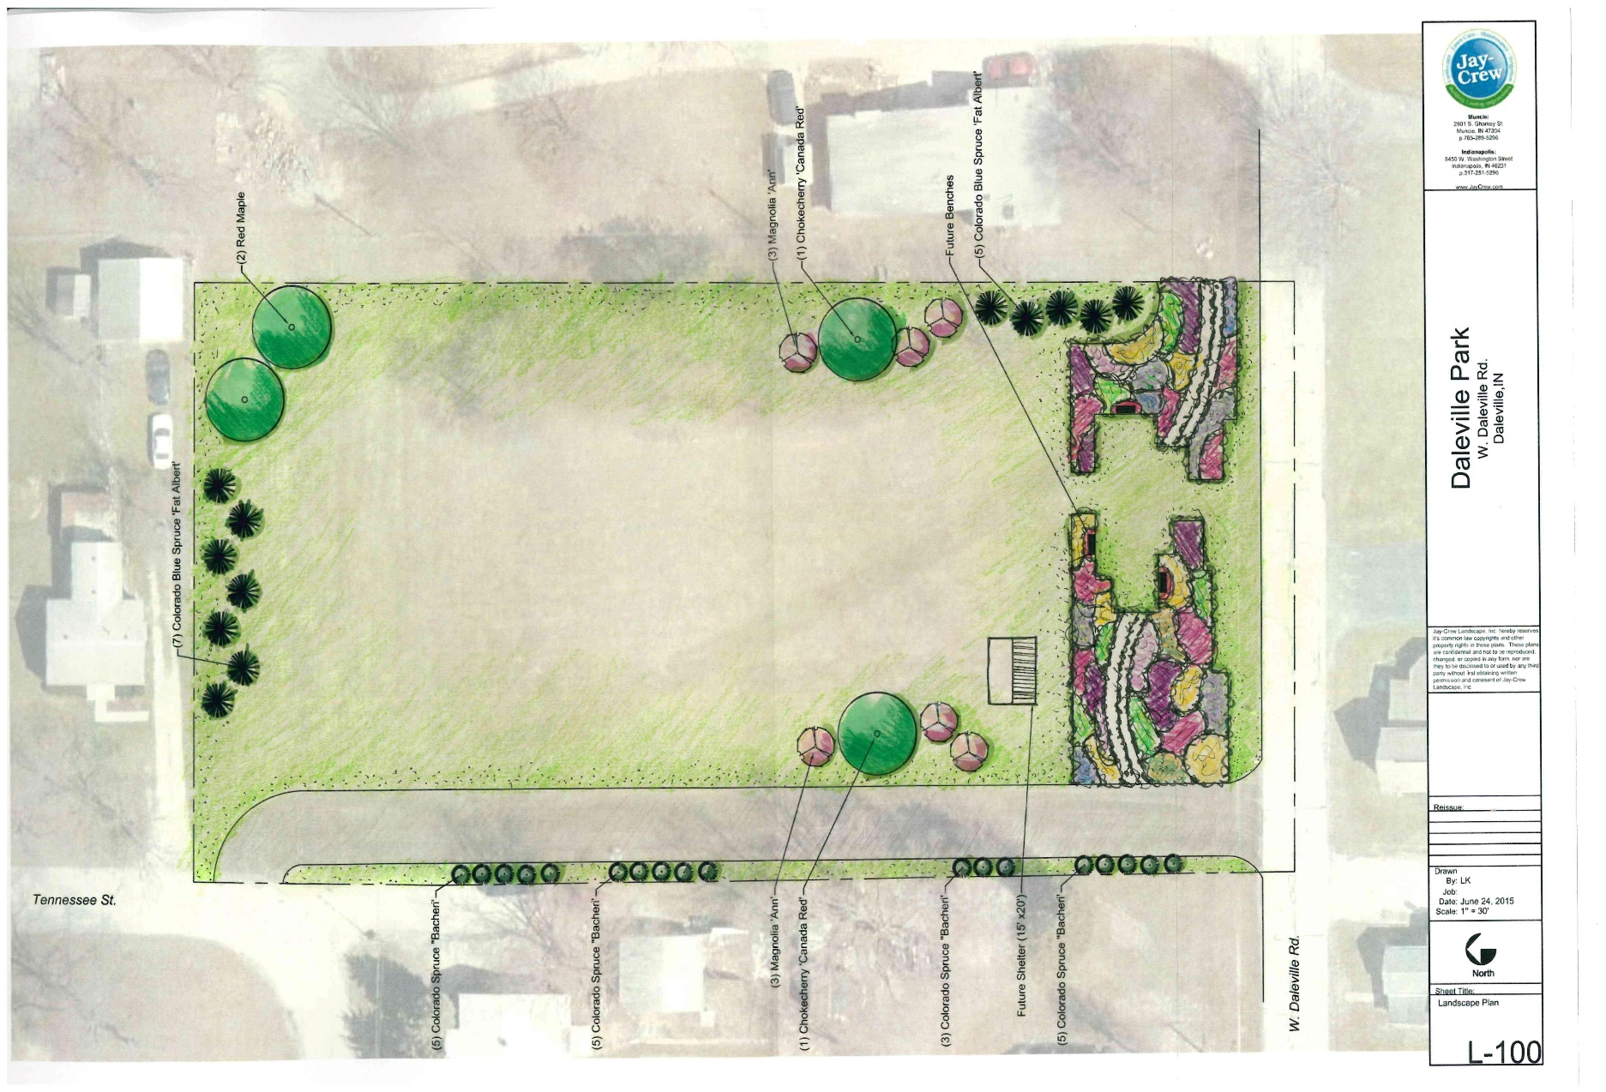

# Handicap Accessibility and Universal Design

**Shellabarger Park**

Achieving and maintaining ADA compliance at Shellabarger Park is a significant concern for Daleville. There are a few modifications that require some time and money to complete. Modifications include marking at least one van-lift accessible parking space, providing braille on signage, and providing at least one handicap accessible picnic table per shelter. There is currently no landings for the main sloped pathway that provides access from the parking area to the park amenities. Five by five foot landings are required every six feet of ramp to provide a break for wheelchair access. Installing these landings at each six foot interval of ramp will be a modification that will require a significant financial investment. Furthermore, locations for ramps with tactile strips should be identified and installed from the road to the parking lot. Overall the infrastructure for this facility will require these modifications to achieve compliance with the ADA.

**Town Hall Park**

Both the shelter and gazebo allow direct access with compliant ADA paths, but the play equipment does not. A second modification includes the installation of a path that is at least 36 inches wide to the play equipment. This pathway would be the most time and cost intensive modification for the park. As part of the proposed Splash Pad project, the Parks Department should also include a new handicap accessible path to the Splash Pad.

Information about Daleville’s efforts to achieve and maintain ADA compliance throughout the town are documented in the 2013 ADA transition plan found online and on the Town website [www.dalevilleindiana.org](http://www.dalevilleindiana.org). For more information about Daleville’s efforts please contact Amy Roberts, Town Clerk-Treasurer. Her contact info can be found below:

**ADA contact official**

Name/Job Title: Amy Roberts/Clerk-Treasurer

Address: P.O. Box 567, 8019 S Walnut St, Daleville, IN 47334

Phone number: (765) 378-6288

E-mail: [aroberts@daletown.comcastbiz.net](mailto:aroberts@daletown.comcastbiz.net)

# Public Participation

**Types of methods used:** Internet surveys, Town council meetings, 2013 OCRA Town Wide Vision Session, Interviews, Parks Board Discussion, 2014 Daleville Master Plan

Date(s) and location(s) of the survey, meeting or interviews:

Internet Survey – Open from 7/15/14 to 8/13/14

2013 OCRA Town Wide Visioning Session – 5/8/13 - Daleville High School

Interview with Jay Shellabarger/Park Liaison – 7/8/14 @ Innovation Connector in Muncie, IN

Town Council Meetings – 6/16/14, 7/14/14, 8/11/14, 9/8/14 Town Hall

Parks Board Discussions - various - Town Hall

Daleville Master Plan Steering Committee Meetings- 4/23/14, 6/17/14, 8/7/14 Town Hall

2014 Daleville Master Plan Public Input Presentation - 8-28-14 Daleville High School

Number of surveys sent: N/A Distributed Online

Number of surveys returned: 10

Number of people/groups interviewed: 5

Number of members of the public attending public meetings: 10-40

**How did you advertise the meeting?** All meetings in Daleville have multiple methods of which they are advertised. In all cases above, meetings were posted in the local newspaper, posted at the Town Hall, announced at other town meetings, and posted on the town’s website.

**How many members of the actual public showed up?** At the various meetings, attendance ranged from as few as two at Park Board meetings, 8-15 at Town Board meetings and up to 50 at the OCRA Visioning Session and Master Plan Public Input Presentation.

**Comments and issues discussed by the public at the meetings and interview:**

1. Town Hall Park needs a Splash Pad
2. Parks need connectivity to the downtown, school and sports complex
3. A connectivity walking/biking trail is needed to connect the town.
4. Not enough festivals
5. Youth and senior extracurricular opportunities are lacking
6. Town adopt the Rundell Ernstberger Master Plan
7. More Green Spaces, Community Gardens, Permaculture Gardens
8. Demolition and removal of blighted and abandoned structures.
9. Year-round events shelter
10. Shelter for Farmers Market

# Internet Survey Results

The Daleville Parks Department conducted an internet survey as a way to gather information from the general population about their desires for the future of the parks department. We chose this method as we feel that it is the best way to reach the most people. The availability of the survey was announced at the July 17th Town Council Meeting in which all in attendance were made aware that they could take the survey. In addition to this announcement, anybody who is part of the town website email listing received notices about the survey being available.

Through these efforts, we were able to get 10 responses to the survey from various members of the public. The town did not have the resources available to distribute the survey in a physical manner. Nor could we carry out any other marketing efforts besides word of mouth due to a limited budget and time constraints. Despite this, the town was able to get enough surveys to identify trends and key areas that the parks department should focus on to better address the needs of the town.

The survey results indicated that there are several issues that the citizens would like to see addressed. The biggest conclusion that was gathered is that the survey respondents strongly desire a Splash Pad to be installed in the Town Hall Park as a way to better serve the youth population with a summertime activity. This project has been mentioned before in town hall meetings, and by other members of the public. This project shall be a priority and receive the full attention of the Parks Department in order to see it come to fruition in the near future. Another key take away from the survey is that the citizens are willing and ready to pay more to support the parks department, even if this means paying an additional tax to do so. This says a lot about the residents and their desire to see the community recreation system grow and better serve the needs of all citizens. The citizens also expressed their desire to have more walking paths installed around town and in the parks, which is why the town has begun construction of new sidewalks and pathways around town and in Shellabarger Park. The last major take away from the survey is that residents are overall satisfied with the current status of the park program. This is a great position to start from as it will allow the Parks Department to grow without much public resistance to new programs and ideas. It is also great because it means that the department can focus on developing the current facilities without having to add/buy new park space.

# Needs Analysis

Total acres of local parks and recreation land is: 10 Acres

Total population by the most recent US Census is: 1636

The most common needs or desires expressed by the public during public participation methods are:

1. Splash pad
2. Trails and paths
3. Youth and Senior Programs
4. New playground equipment
5. More benches and shelters

The top five most common needs or desires as listed by the park board/park staff are:

1. Larger budget
2. Splash Pad
3. More trails/walking/bike paths to connect to the town, school and sports complex
4. Enact the Rundell Ernstberger Master Plan
5. Fill in the Town Hall Park ditch
6. Surveillance camera equipment to deter vandalism
7. Mini-amphitheater

# Daleville Dream Project

The dream project for the town of Daleville would be the complete renovation of Town Hall Park. This project is part of the Downtown Revitalization Plan Project that was developed by Rundell Ernstberger & Associates. The newly renovated Town Hall Park would include all of the amenities that were mentioned by the public during meetings, interviews, surveys, and forums. These include things like a splash pad, farmers market, amphitheater, walking and biking trails, and more playground and exercise equipment. The goal of the project is to completely renovate the entire town hall property and develop it into a much more functional and aesthetically pleasing space.

The city has $4.2 million available from the issuance of a 2015 TIF Bond to finance the renovations. The town will also seek to utilize these funds as leverage and matches for grants as a way of stretching each dollar even further. The new park is intended to be a point of pride for the townspeople, and provide the recreational amenities that people look for when deciding to locate in a community. It is the belief of the Town Council that a focus on making the town more aesthetically pleasing, pedestrian/bike friendly, and entertaining will attract people to both live and visit the town, thus increasing the town’s tax base and economic prosperity. Final completion of the project is expected to happen in 2016 and the final architectural renderings are expected to be completed in the fall of 2015. Rough drafts of the new park, proposed trail network, and town revitalization strategy can be found on the next pages.

**Town Hall Park Revitalization Draft**

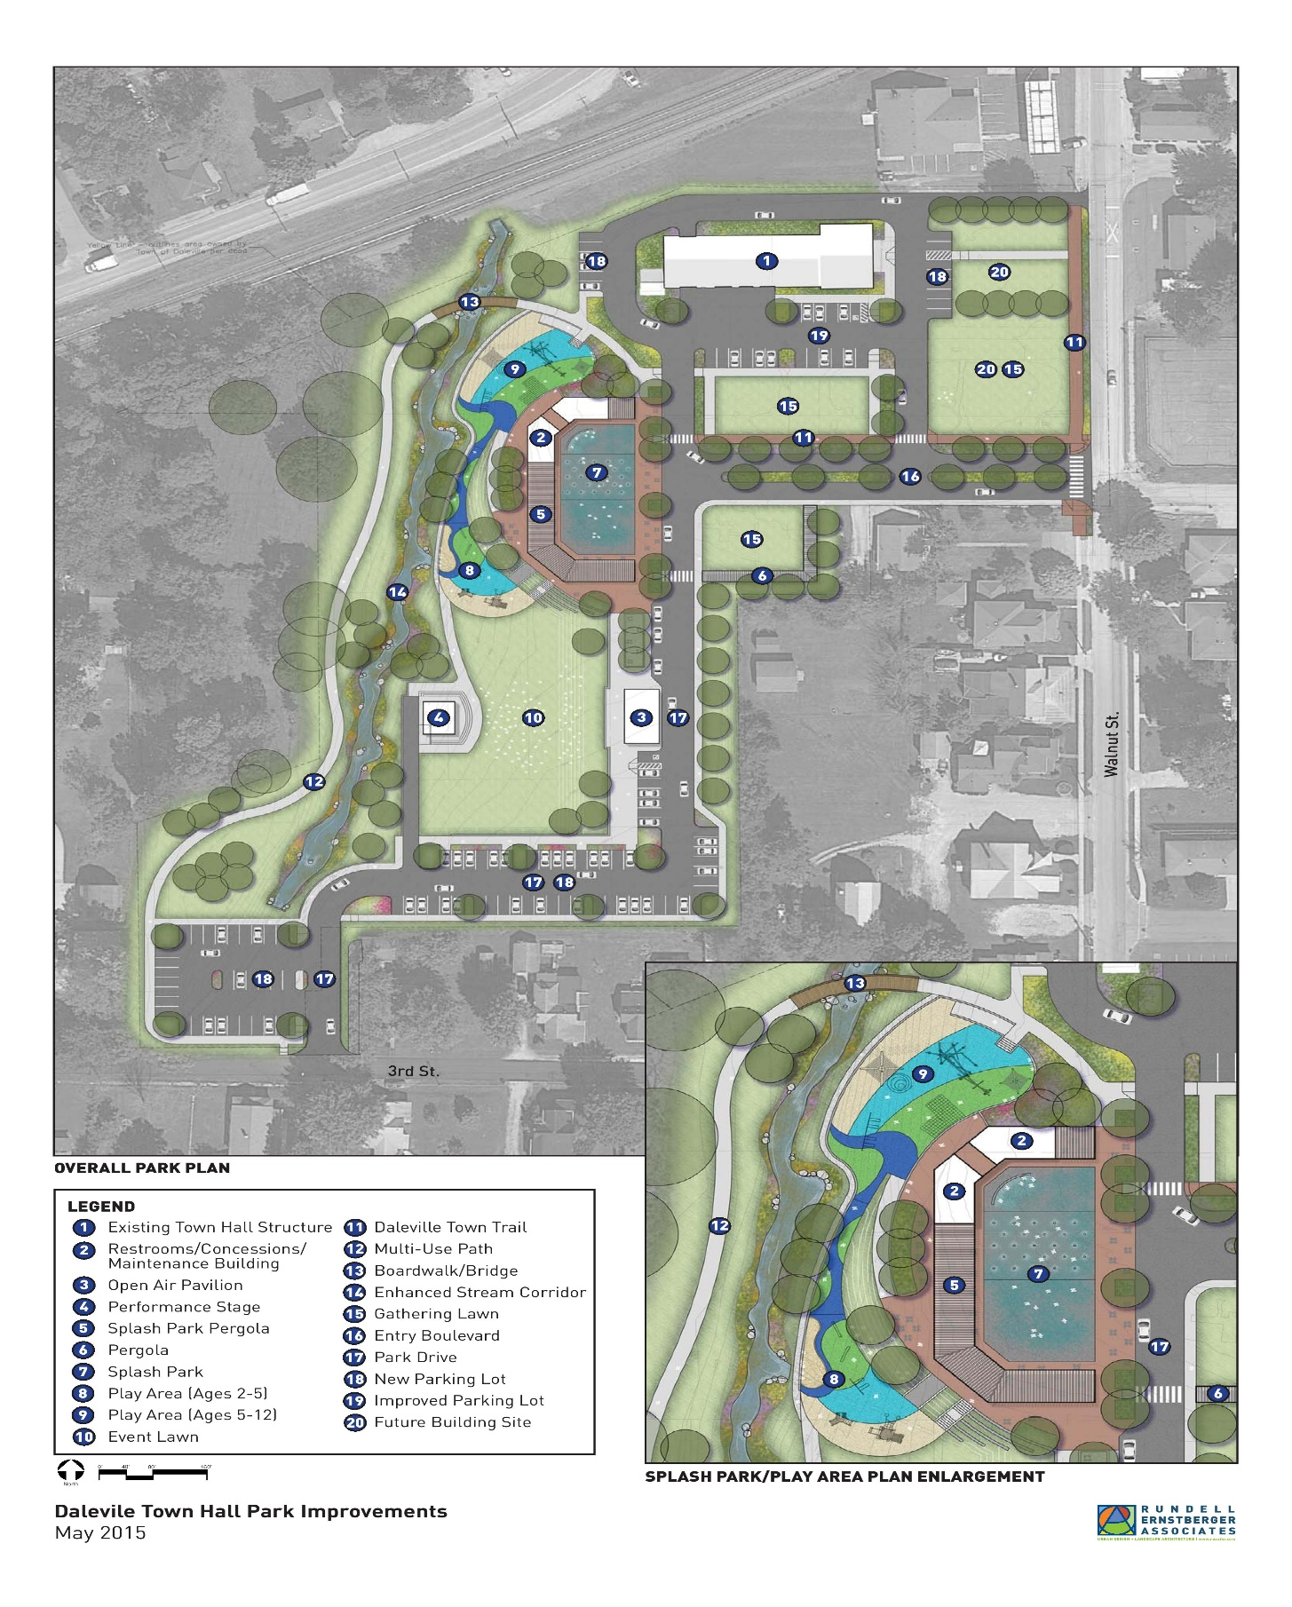

**Proposed Trail Network**

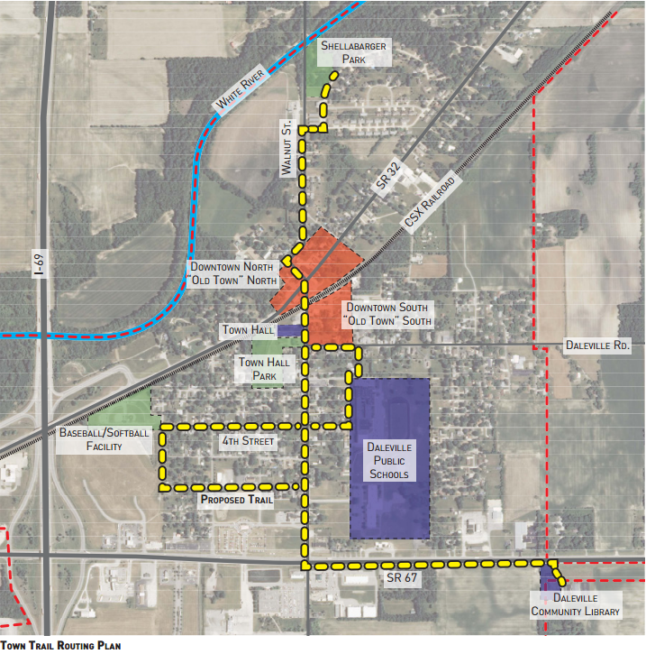

**Community Wide Master Plan Proposal**

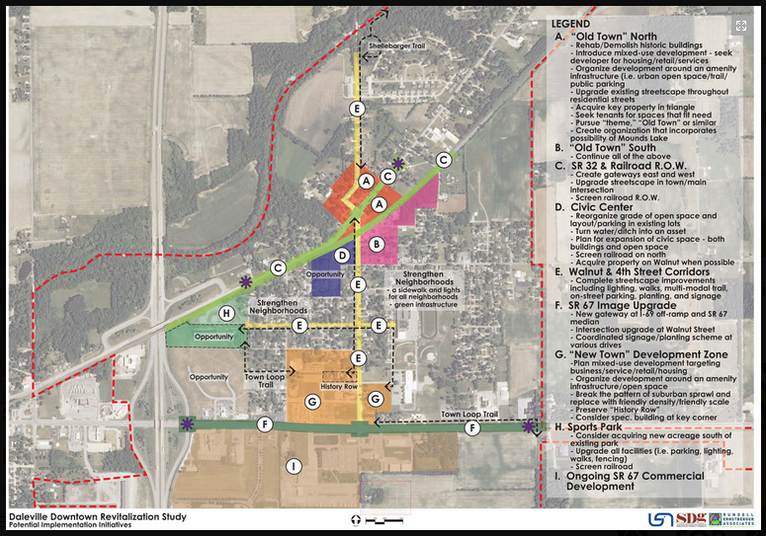

# Priorities and Action Plan Schedule



# Appendix Survey Results

